Oscar Reinitz, Dominic Saleh

Prelim SDD Major Project Documentation

# Allocation of Tasks

Gantt Chart: Oscar

Screen Designs: Oscar

Data Dictionary: Dominic

HTML and CSS setup: Oscar

Javascript Local storage: Dominic

Javascript Sort: Oscar

# Logbook

# Gantt Chart

# Screen Designs

# Data Dictionary

|  |  |  |  |  |  |
| --- | --- | --- | --- | --- | --- |
| Variable Name | Data Type | Scope | Length | Description | Example |
| subjectsCode | Object Array | Global – search.js | 40 | Contains the name codes for the 40 available subjects | “enStand” |
| selectedSub | Array | Global – search.js | Varies 0-8 | Holds up to 8 subject name codes when they are selected | “enStand” |
| subjectHeaders | Array | Global – search.js | 13 | Contains the subject header name code for usage in hiding divs | “headEn” |
| searchTerm | Integer from HTML element | Local – search.js | Varies | The string that the user enters into the search bar | “Advanced English” |
| tempTerm | String | Local – search.js | Varies | Holds a the resulting simplified version of the search term from the simpTerm function | “enAdv” |
| searchResult | String | Local – search.js | Varies | Holds the resulting name code from the binary Search function | “maAdv” |
| items | String | Local – search.js | Varies | Sorted array for the binary search algorithm | “enAdv maAdv” |
| value | String | Local – Search.js | Varies | Search term for the binary search algorithm | “enAdv” |
| middle | Integer | Local – Search.js | Varies | Used to calculate the middle during the binary search | “4” |
| term | String | Local – Search.js | Varies |  |  |
|  |  |  |  |  |  |
|  |  |  |  |  |  |
|  |  |  |  |  |  |
|  |  |  |  |  |  |
|  |  |  |  |  |  |
|  |  |  |  |  |  |
|  |  |  |  |  |  |
|  |  |  |  |  |  |

# System Flowcharts:

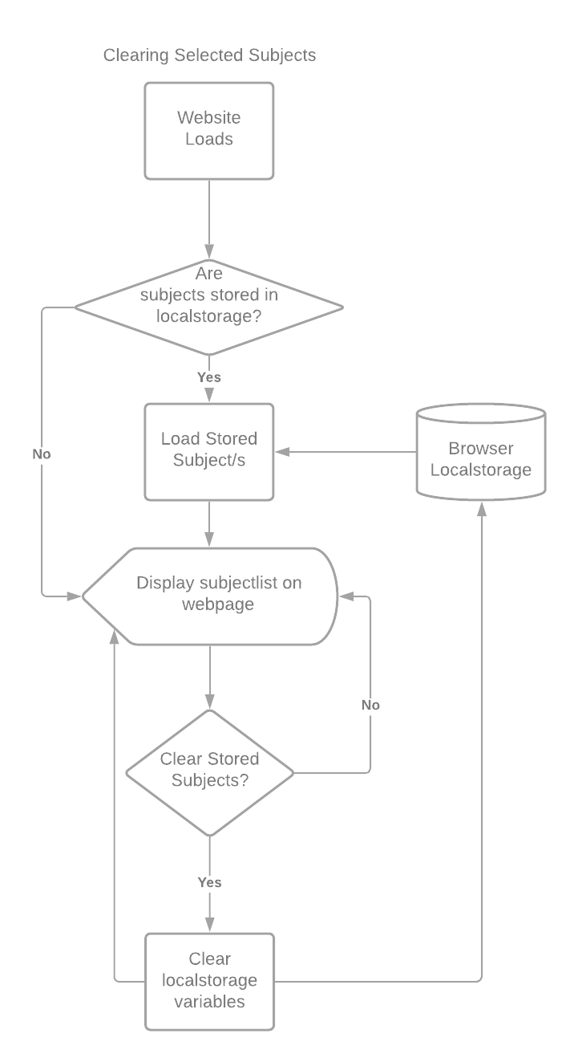

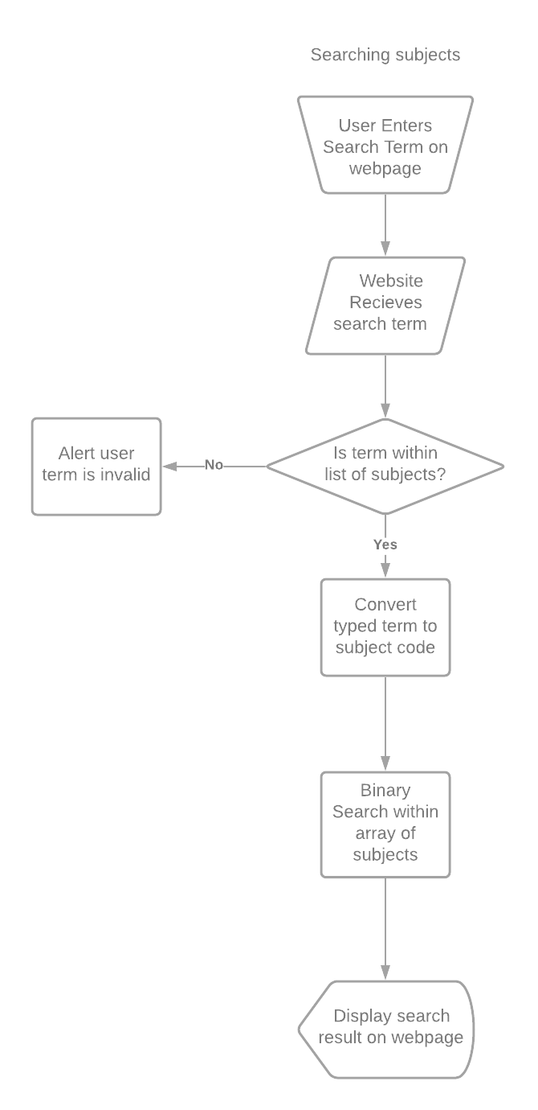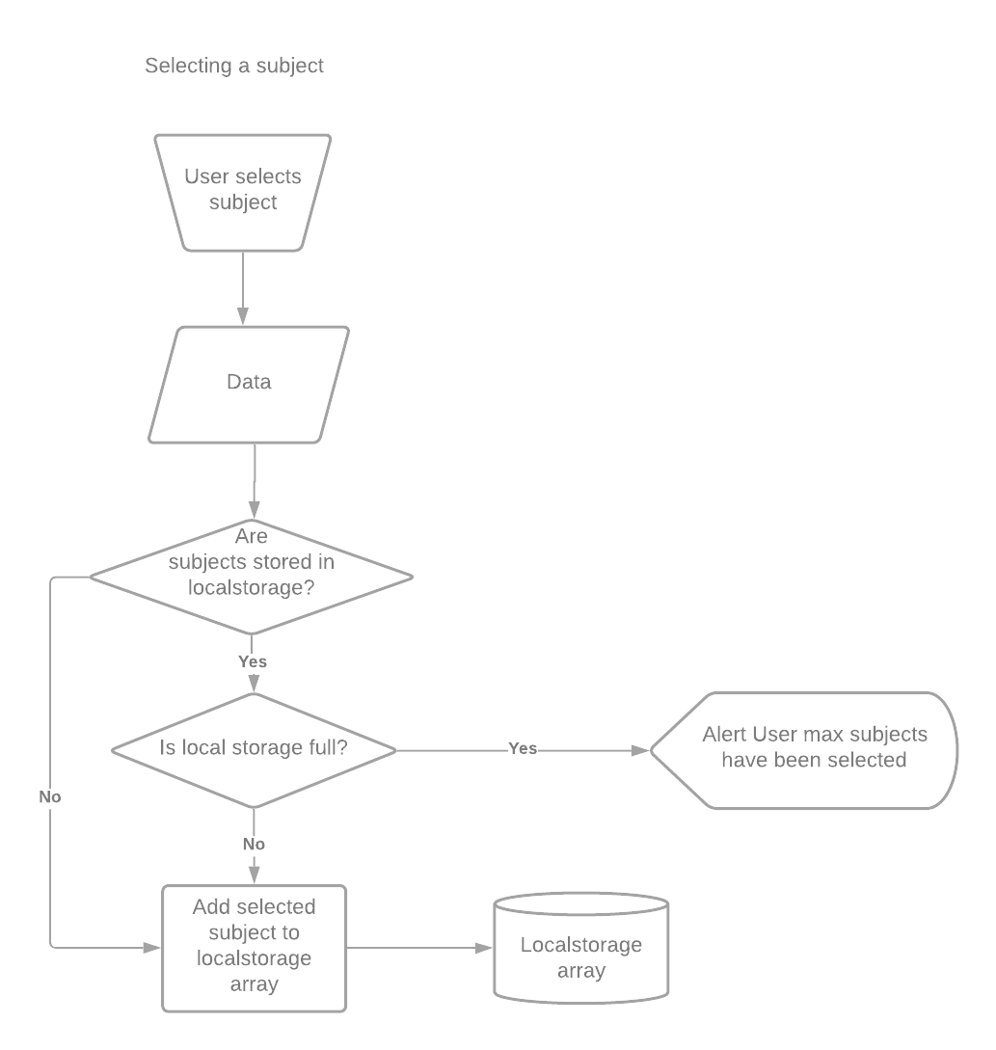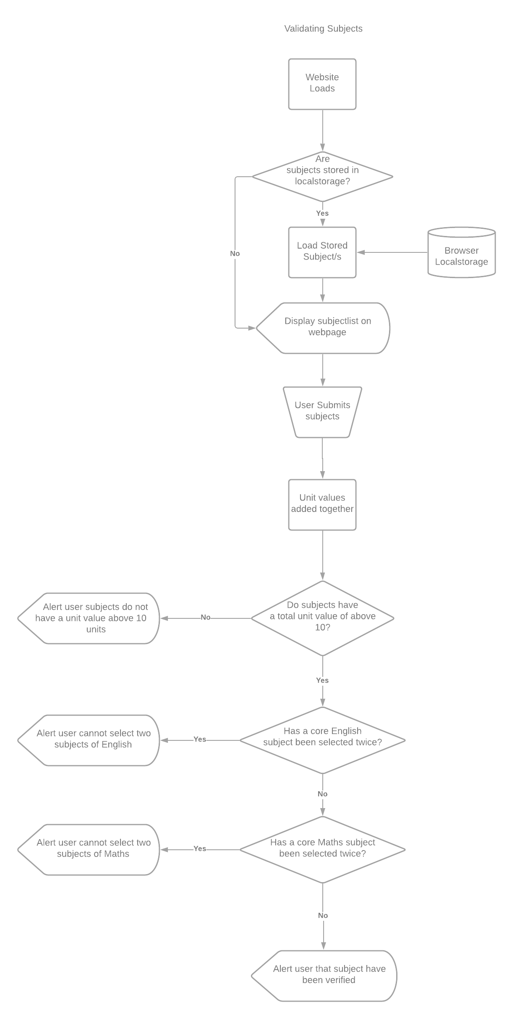

# Data Flow Diagrams

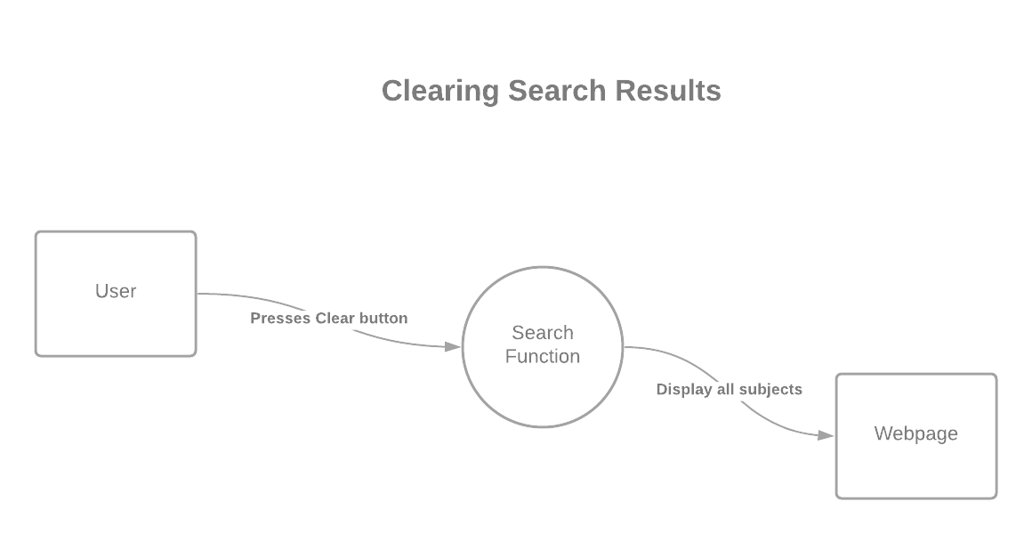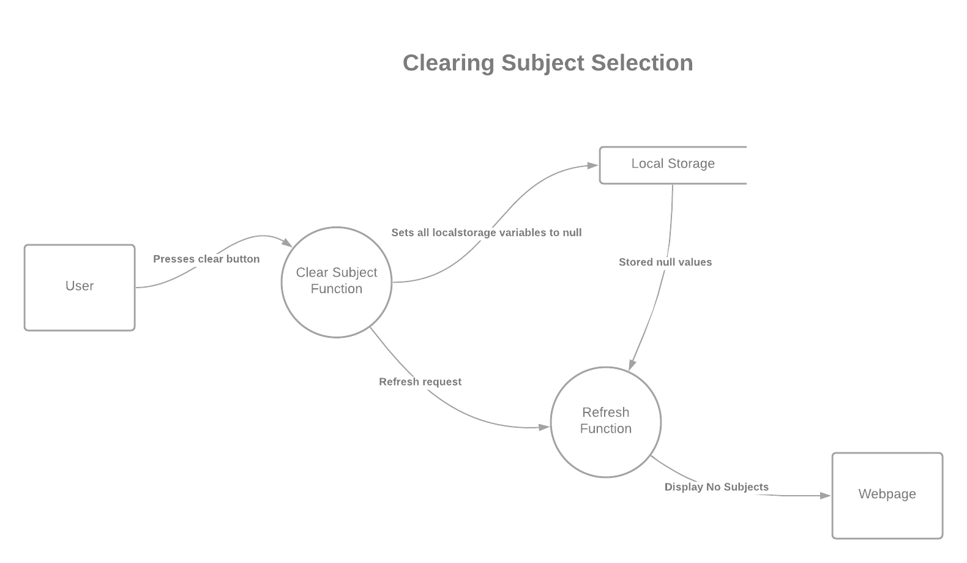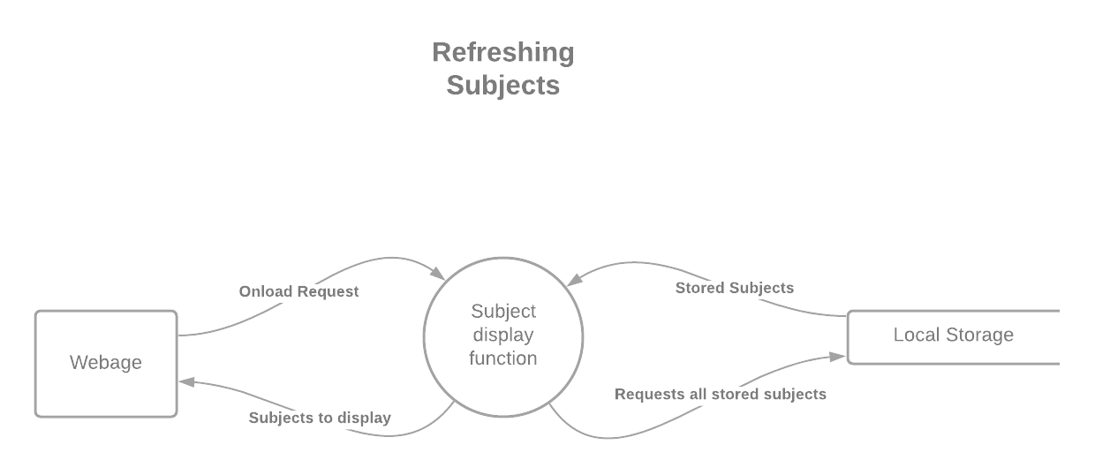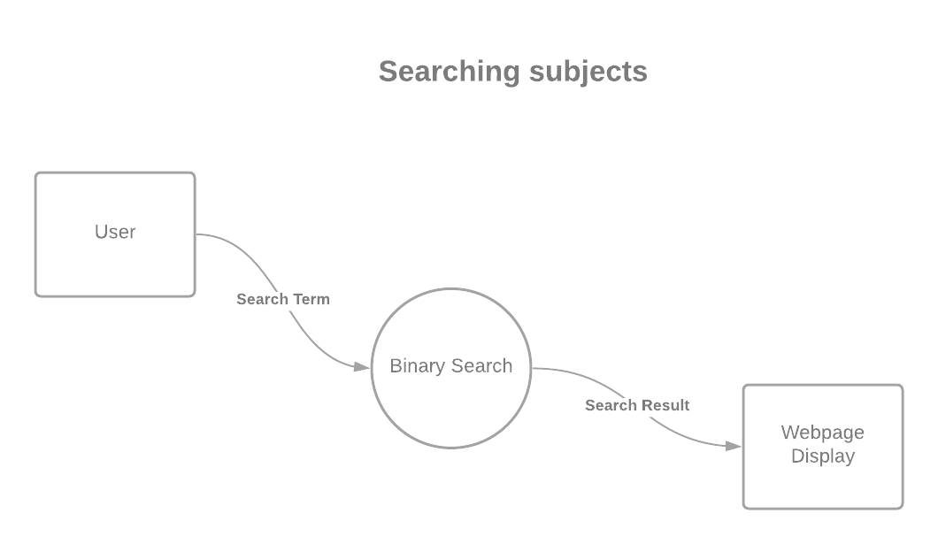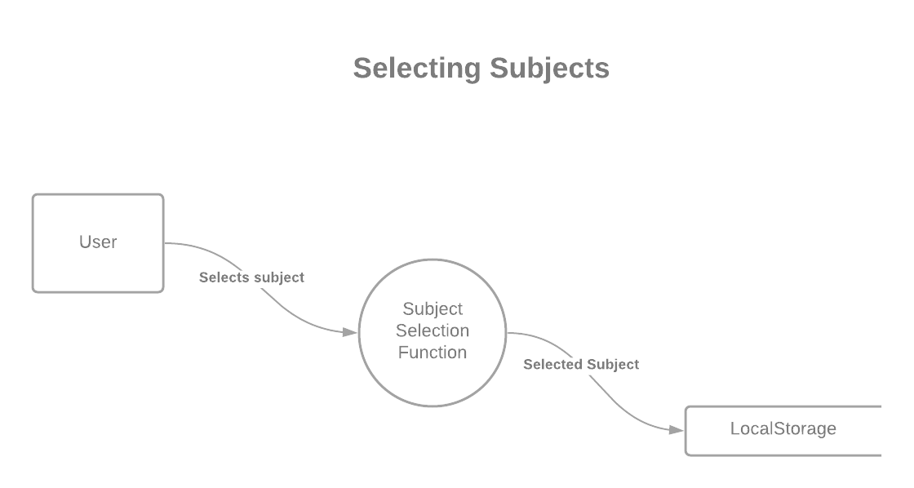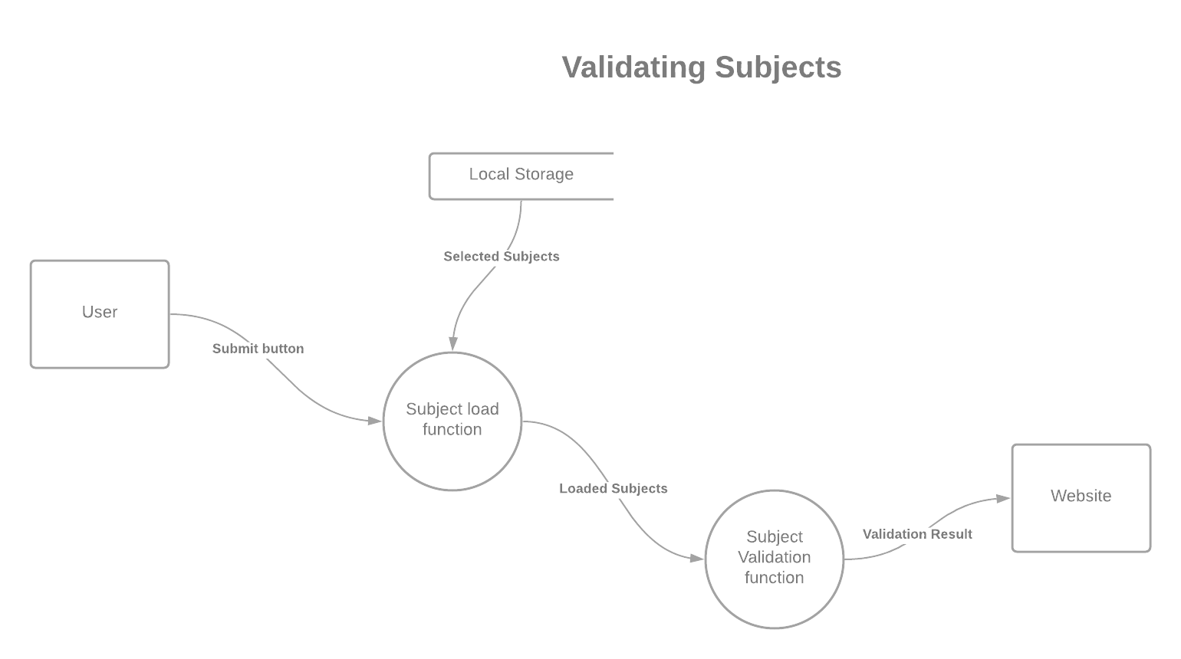

# Structure Chart

# Evaluating The Solution